#### Family List (Empty)

Nielsen’s:

**Visibility of system status ✓**

**Match between system and the real world ✓**

**User control and freedom ✓**

**Consistency and standards ✓**

**Error prevention ✓**

**Recognition rather than recall ✓**

**Flexibility and efficiency of use ✓**

**Aesthetic and minimalist design ✓**

**Help users recognize, diagnose, and recover from errors ✓**

**Help and documentation ✘**

It’s not clear what any of the two buttons do, or even their capabilities. For instance, there’s a limitation to “Adding new family members”: this can only be done when they’re nearby. We need users to understand this, so that they are not forced to “try and fail” if there’s no internet.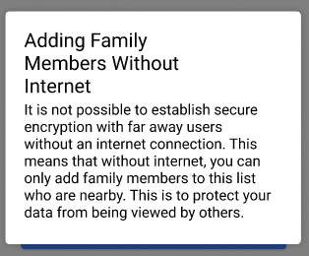

Fix: Add an explanation that tells the users that they cannot add new family members who aren’t near them at the moment if there’s no internet connection. Make this explanation clickable (and add a question mark button to make it clear that it *is* clickable), and show more information on click in the form of a popup.

Our own:

**Offline tolerance ✓**

**Battery efficiency ✓**

**Calm computing ✓**

**Physical Simplicity ✓**

**Memory and Attention ✓**

**Attitude Towards Risk ✘**

Users may be unsure if “search for others” will immediately reveal their location or information to others. More information is available on the next page that explains how the application works, but the users can’t read this information without tapping “search for others”. We want to make it clear that “search for others” is not a destructive action, and that it’s safe for users to proceed to the next page.

Fix: Add text: “Tapping “search for Others” does not yet start the search”.

**Communication and Collaboration ✓**

#### Search for others

Nielsen’s:

**Visibility of system status ✓**

**Match between system and the real world ✓**

**User control and freedom ✓**

**Consistency and standards ✓**

**Error prevention ✘**

The original design had no guard on pressing “enable”. This meant that a user could accidentally start sharing their location with everyone around them with a simple misclick.

Fix: when the feature is enabled, show a confirmation dialog that ensures the user knows that they will be sharing their location with people outside of their family circle. This also helps improve the Risk heuristic.

**Recognition rather than recall ✓**

**Flexibility and efficiency of use ✓**

**Aesthetic and minimalist design ✓**

**Help users recognize, diagnose, and recover from errors ✓**

**Help and documentation ✓**

Our own:

**Offline tolerance ✓**

**Battery efficiency ✓**

**Calm computing ✓**

**Physical Simplicity ✓**

**Memory and Attention ✓**

**Attitude Towards Risk ✓**

**Communication and Collaboration ✓**

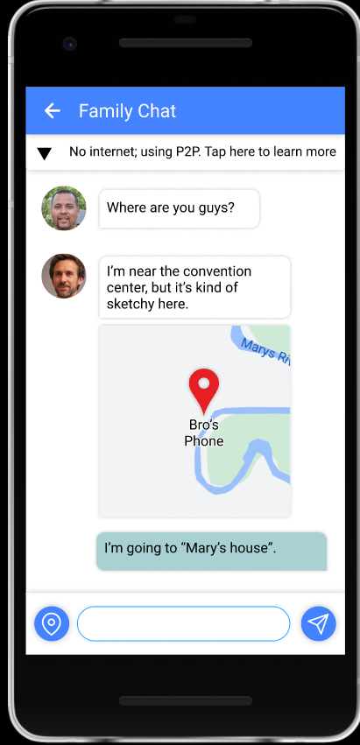

#### Chat

Nielsen’s:

**Visibility of system status ✓**

**Match between system and the real world ✓**

**User control and freedom ✓**

**Consistency and standards ✓**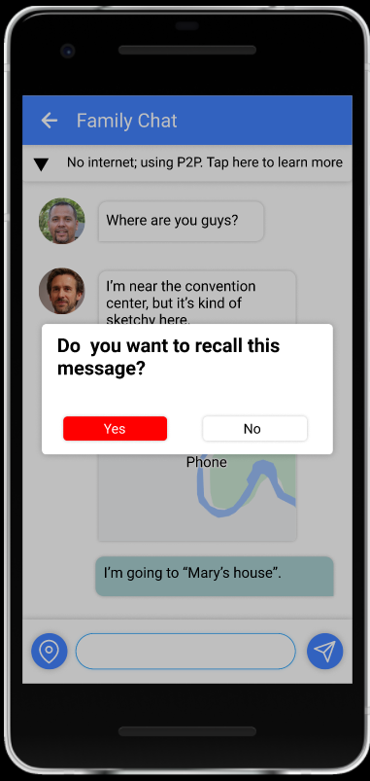

**Error prevention ✘**

The user is allowed to recall their message like a normal chat app.

Fix: We add an overlay when the user holds on to the message they sent, the overlay will ask the user if they want to recall their message.

**Recognition rather than recall ✓**

**Flexibility and efficiency of use ✓**

**Aesthetic and minimalist design ✓**

**Help users recognize, diagnose, and recover from errors ✓**

**Help and documentation ✓**

Our own:

**Offline tolerance ✓**

**Battery efficiency ✓**

**Calm computing ✓**

**Physical Simplicity ✓**

**Memory and Attention ✓**

**Attitude Towards Risk ✓**

**Communication and Collaboration ✓**